Barnsley and Dearne Valley BSAC Divers Open Water Training Day

Capernwray Sunday 18th August 2019

Address

Jackdaw Quarry, Capernwray Rd, Over Kellet, Carnforth LA6 1AD, UK
Tel: 01524 735132

Directions

Leave the M6 at junction 35 and turn right onto the A601M. At the T junction turn left towards Over Kellett. In the village turn left onto Capernwray Road until you come to Jackdaw Quarry on the right. (Take care down the narrow lane, you may meet the back of the queue waiting to enter the site round a corner!)

Arrival Time

The site opens at 9am. Please aim to be there just before 9am to bag a good parking spot…the best area is to the right as you enter the site. Look out in that direction for your instructors and try to park near them. The site closes at 5pm.

Cost
If you are already a member it costs £12 to dive. If it is your first visit then you will have to pay an additional £5 for the day’s diving. (Alternatively you can pay £25 for lifetime membership avoiding the extra £5 the next time(s) you come). There is no charge for non-divers.
Air is £5 per fill.

What you will need:
- Wetsuit
- Hood & Gloves
- Fins
- Mask
- BCD
- Regs
- Cylinder
- Weights
- DSMB+Reel (Sports Divers only)
- Slate+compass (Sports Divers only)
- Dive Computer or BSAC Tables
- Your qualification and log books!!
The current water temperature is between 16-18 ºC. So a 5 or 7mm wetsuit should be comfortable. You can hire the complete diving kit package from Capernwray (£35 including a wetsuit) but you have to book this in advance of the day. Go to https://www.dive-site.co.uk/gear-hire for information.

Alternatively you can hire just the protective clothing from Capernwray and hire the SCUBA from the club. This may work out more expensive but you will have a BCD that you know fits you well.

If you have your own protective clothing it is definitely cheaper to hire the SCUBA and weights from the club but you have to pick them up the Tuesday before.

Remember to bring towels and sun cream (being optimistic)! Also, please make sure you bring something to drink to keep yourself hydrated between dives. Snacks and drinks are available at the café but bring plenty of water.
The site

Site description
An inland, fresh water dive site with the following facilities.

On site shop and cafe
Free Parking.
Fully Charted Dive Site
Platforms for training.
Changing Rooms.
Equipment hire
Numerous underwater attractions
Service Centre for Scuba Equipment.(not open on Sundays)

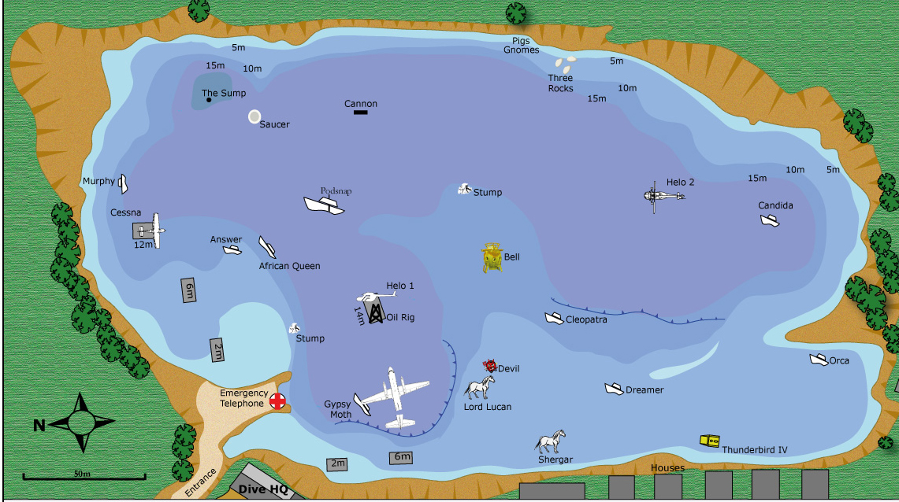
Objectives for the day

- To complete DL training with Mick G (DO7)
- To complete at least two training dives with all OD and SD trainees
- To provide DSMB deployment practice for those who need it.

Instructors:

David Patchett,
Paul and Pam Tarn,
Ann Bailey,
Sammy Norton
Dave Corbett
Possibly Chris S and/or Richard S.

Ocean Diver Trainees

Barnsley:
Debbie Senior
Mackenzie Batley
Dominik Szucs
Henry Chapman
Ruby McHale

Dearne Valley:
Ellen Wilson
Alasdaire Jamieson
Andrew Hale

Sports Diver Trainees

Barnsley:
George Valianis
Callum Ellwood
Steve Lane

Dearne Valley:
Marie Hollinshead

Others

Mick Gwilliam
Mate Szucs

Simon Rafferty

If you find you are unable to come on the day or before please let Ann Bailey (on 07796171786) or Pam Tarn (on 07766544032) know me know as soon as possible

Thanks,

Ann and Pam

